Diocese of Meath - Synodal Pathway ONLINE Questionnaire 2022

Parish of residence (optional):

Are you completing this questionnaire after attending a Lenten Synodal Meeting in your local area (delete as appropriate)? YES NO
If “YES”, please give date of meeting:

Are you completing this questionnaire after conducting a synodal conversation with someone else at home, at work, in neighbourhood, etc. (delete as appropriate)? YES NO

Are you completing this questionnaire after conducting a synodal conversation with a group (delete as appropriate)? YES NO
If “yes”, how would you describe the group?
How many were in the group (approx.)?

Please begin by making this prayer to invoke the guidance of the Holy Spirit:

We stand before You, Holy Spirit, as we gather together in Your name.
With You alone to guide us, make Yourself at home in our hearts;
teach us the way we must go and how we are to pursue it.
We are weak and sinful; do not let us promote disorder.
Do not let ignorance lead us down the wrong path
nor partiality influence our actions.
Let us find in You our unity so that we may journey together to eternal life
and not stray from the way of truth and what is right.
All this we ask of You, who are at work in every place and time,
in the communion of the Father and the Son, forever and ever. Amen.

The Synodal Questions
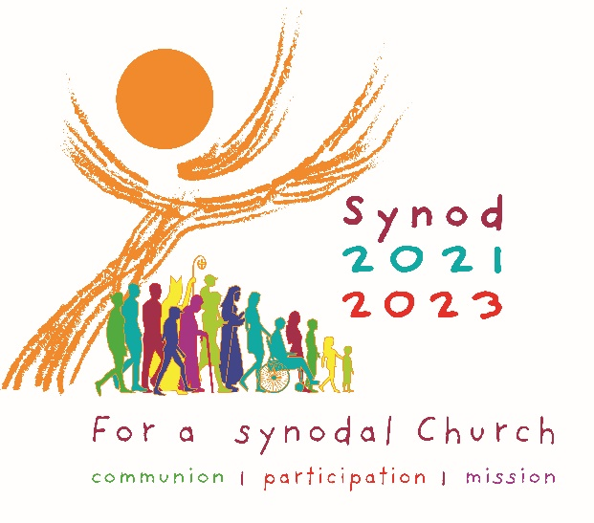
The questions below invite reflection on the theme of the Universal Synod 2023 which is “Communion, Participation, Mission”.
Communion implies a sense of belonging to the Church, and an experience of unity. Participation explores how you feel part of the life of the Church, how you feel valued in the Church, and your voice in the Church. Mission seeks to understand your experience of growing in your faith.
The first question of each pair, i.e. (a), asks about your current experience. The second question, i.e. (b), asks how your current experience could be improved in the future.
I. Communion
(a) To what extent do you experience shared faith, companionship, togetherness, and friendship in your parish?

(b) How can we, as Catholics, create a real sense of welcome, belonging, and inclusion in our parish community?

II. Participation
(a) What opportunities are there within your parish and/or diocese for you to speak freely, to be listened to, and to be heard?

(b) How might new opportunities be developed for the voice of all people to be heard in your parish?

III. Mission
(a) What is your experience of growing in your faith and active sharing in the life of your parish and/or diocese?

(b) How can the parish community form people of faith who desire to be involved in and responsible for the life of their parish community?

Once completed, you can return a printed copy of this questionnaire to your local parish, OR email it to meathsynodalpathway@gmail.com

